**Teknowledge Shared Services Pvt. Ltd**

**OPR for how to use OneNote**

|  |  |
| --- | --- |
| **SUBJECT** | **OPR for how to use OneNote** |
| **DEPARTMENT** | IT Support |
| **RECORDER (Name & Designation)** | Amila Kaushalya |
| **APPROVEDBY (Name & Designation)** |  |
| **CREATED DATE** | 21-Sep-2016 |
| **LAST UPDATED** | 30-May-2017 |
| **PATH ON NETWORK FOLDER** | https://cisintlcom.sharepoint.com/Shared%20Documents/IT_Sup/OPR |
| **NO. OF PAGES INCLUDING THIS PAGE** | 14 |

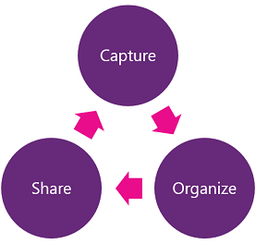MICROSOFT ONENOTE

**Microsoft OneNote is a computer program for free-form information gathering and multiuser collaboration. It gathers users' notes, drawings, screen clippings and audio commentaries.**

Contents

NOTEBOOK ON ONENOTE 3

Start OneNote and create notebook 3

Set Default folder for the NOTE 7

Quick Notes 11

Need to discover more? 14

Microsoft OneNote Tutorial 14

For PC 14

For Mac 14

NOTEBOOK ON ONENOTE

Start OneNote and create notebook

Click on start---🡪OneNote 20**

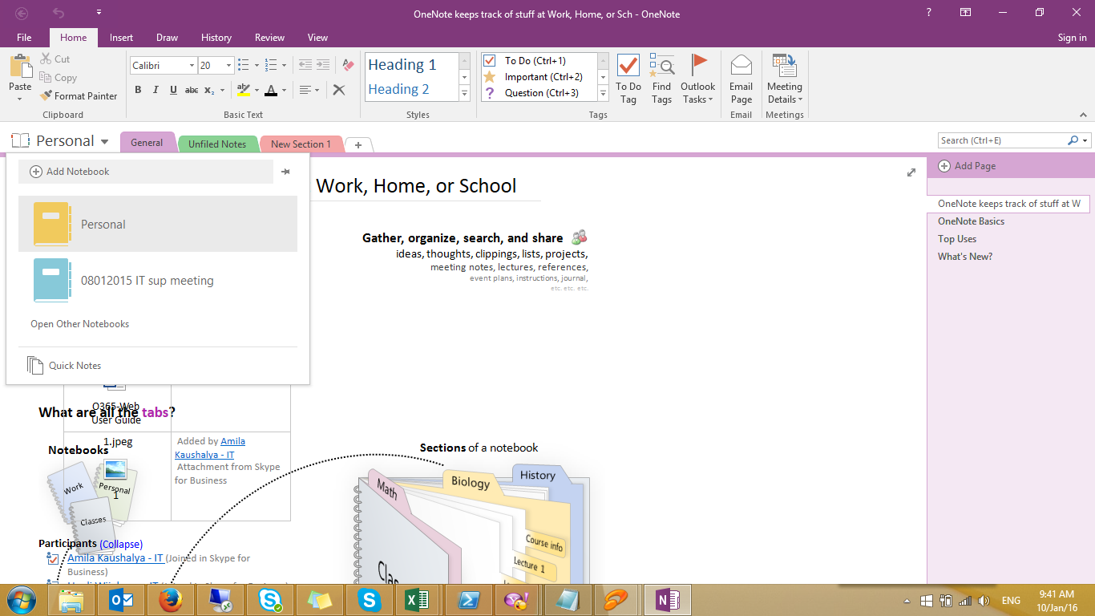

Add Notebook to OneDrive for business folder



Select The location to save your note. Select preferred option and “Create in a different folder”

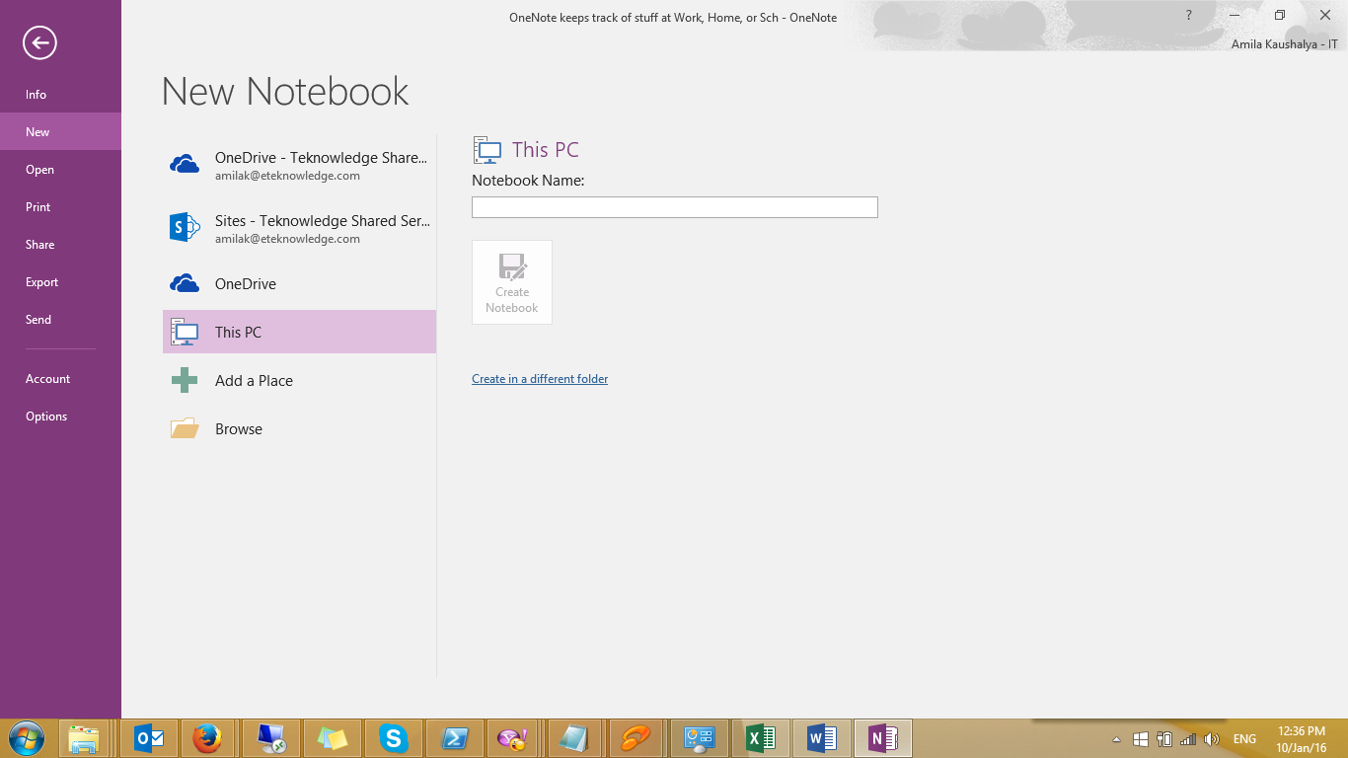



Select the One Drive Folder that you need to save your notebook.

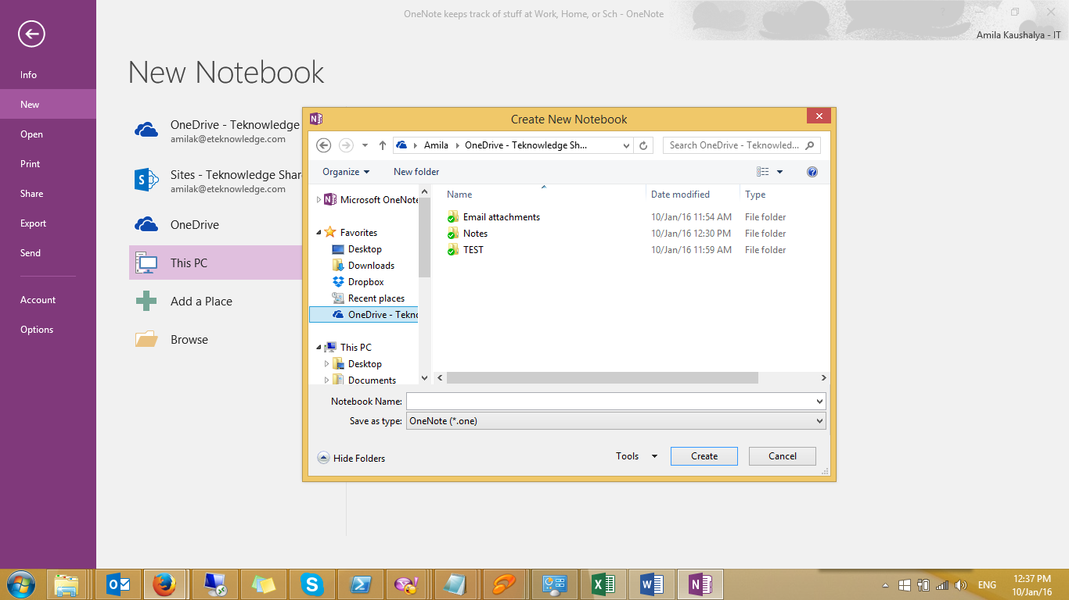

Choose a name for the **Note** and Click **Create**

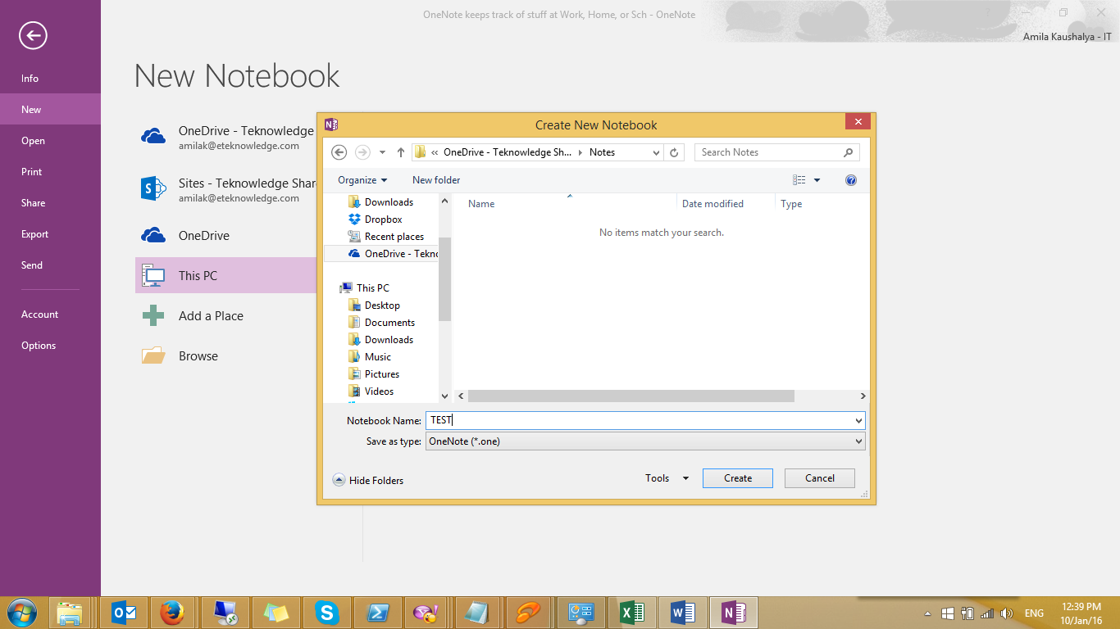

If you wish the note with collages, select **invite people**. Or select **Not now.**

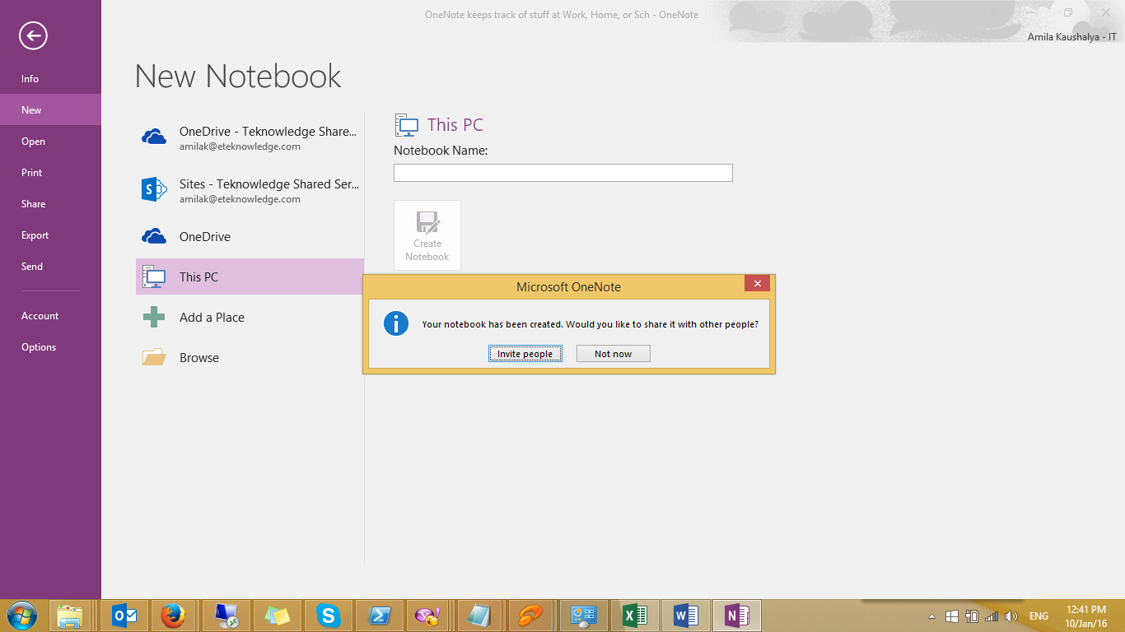

Below is your **NOTE**. You can create **Sections** as you wish for the Note.

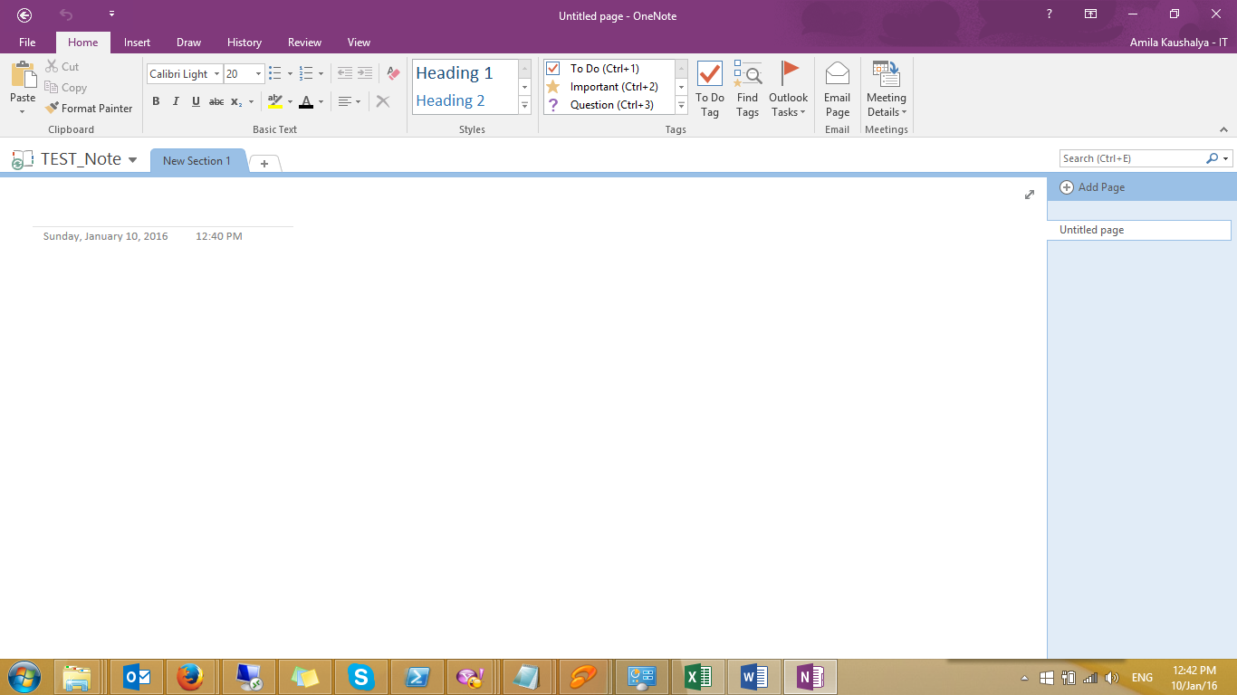

Set Default folder for the NOTE

Open One Note

Tray---------------🡪Right Click On One Note----------------🡪Open OneNote

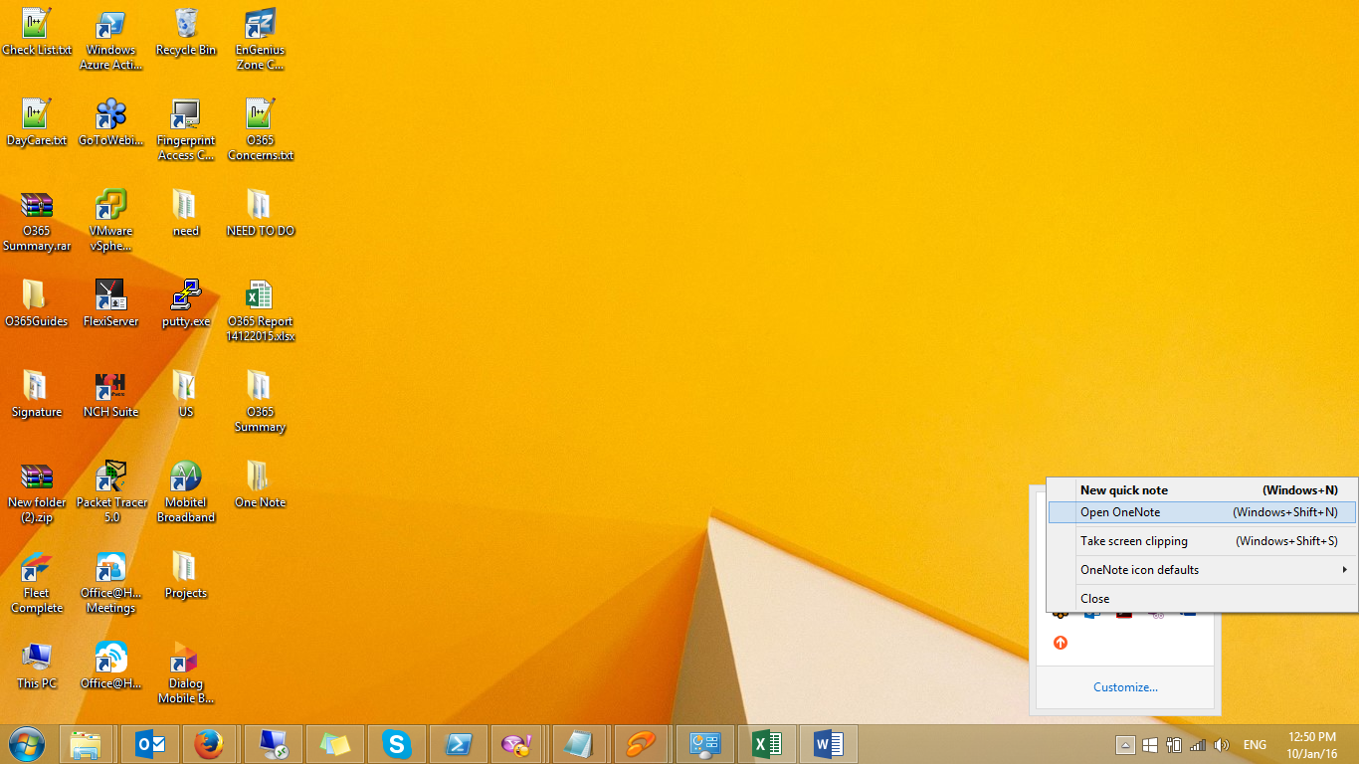

File----------🡪Options

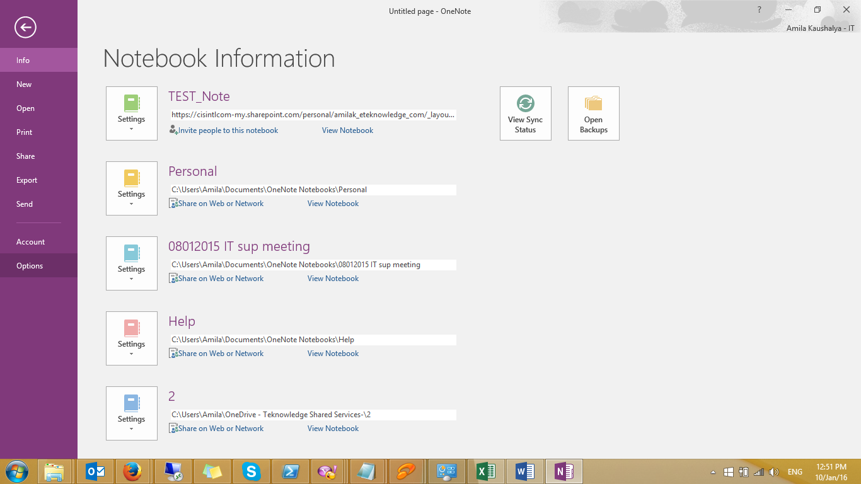

Save and Backup

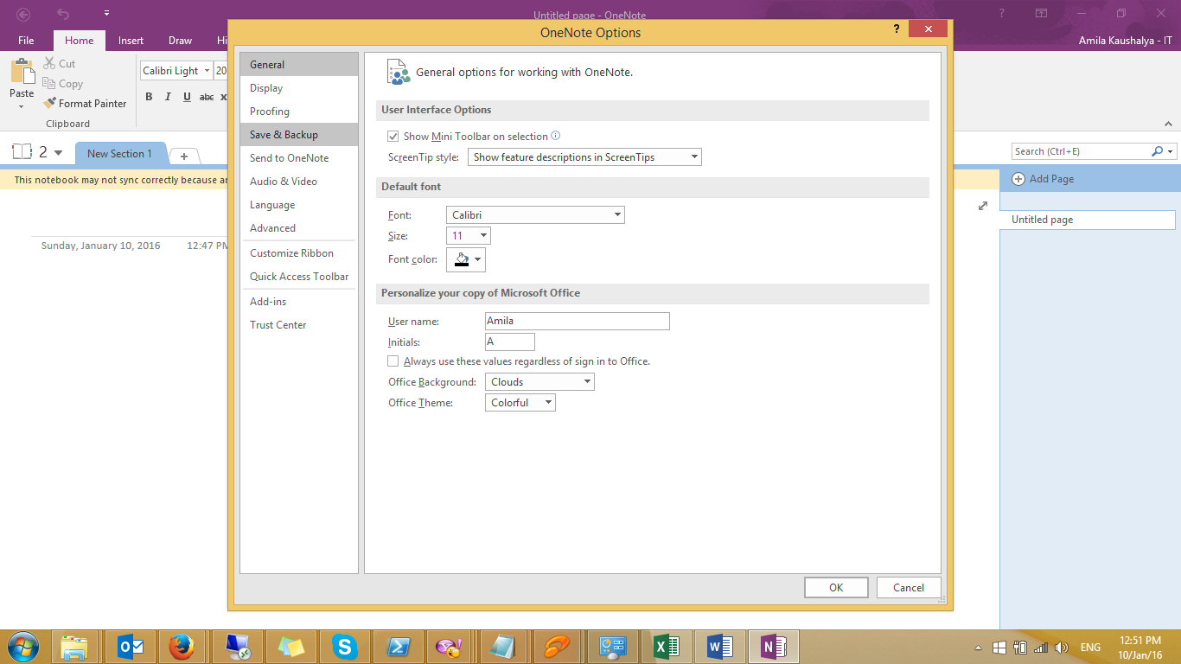

Select Default Notebook Location and click Modify.

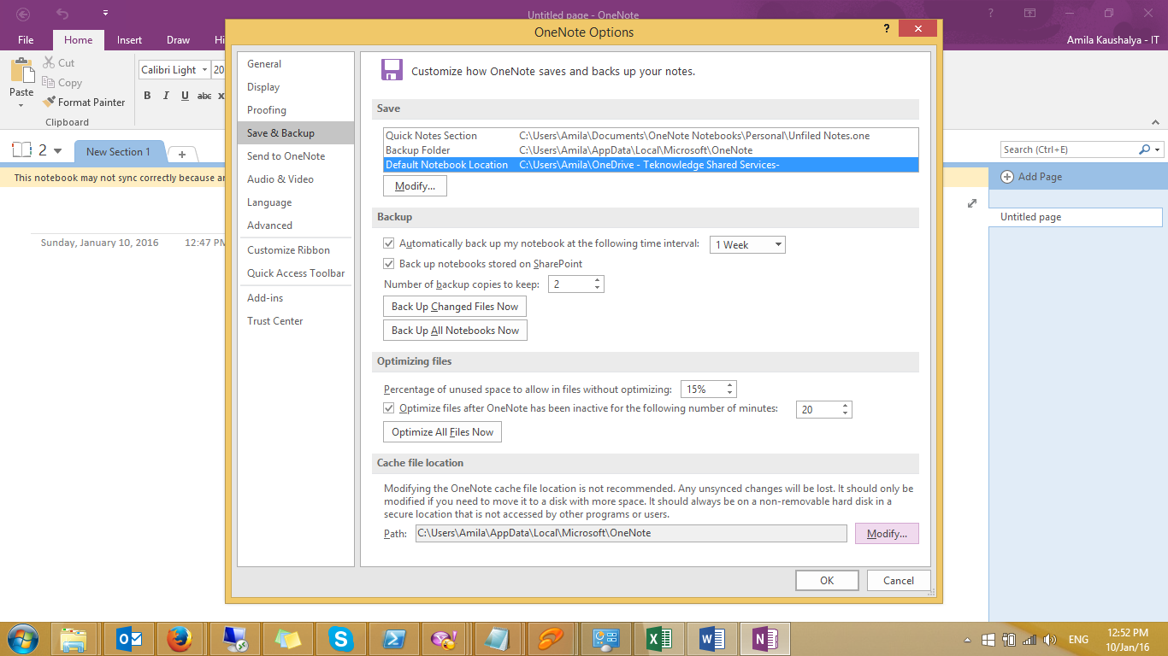

Select **OneDrive for business** and destination folder. (Ex:Notes)

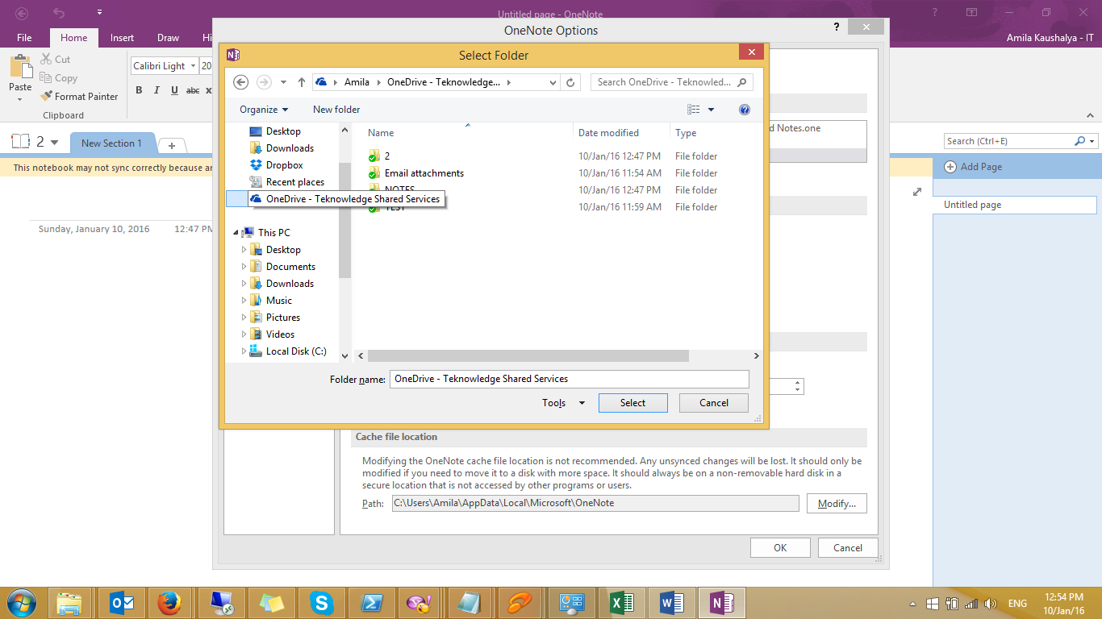

Click Select.

Very Important

* Notes by default appear with First Note on your one note application. You can select your default note. Refer below

1. Drag you default Note in to first of the notes. (Ex: Office should be my default Note)

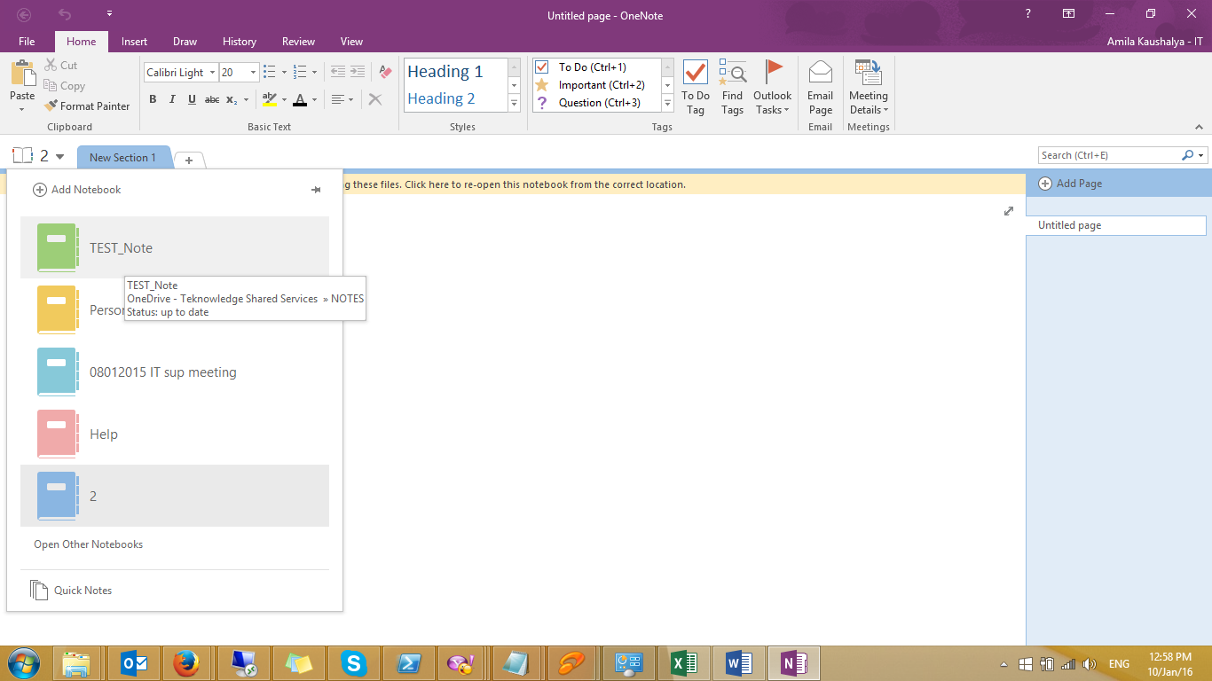

Drag “Office” and move to top of notes section.

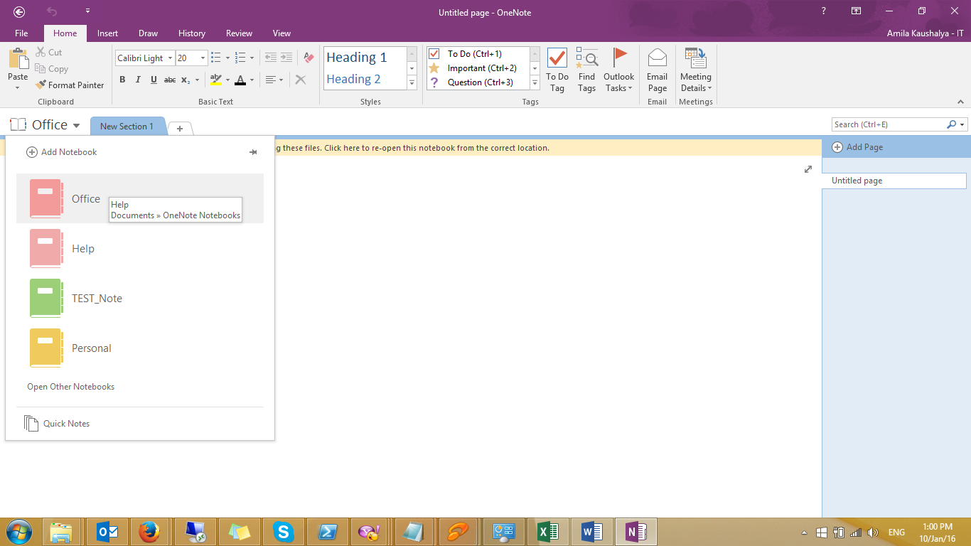

Quick Notes

Quick Notes are great way to note down your all your ideas/quick plans.

Please note by default Quick notes saves on “Personal Note”, Let’s check how to change default quick note path.

File----------🡪Options



Save and Backup



Select **Quick Notes Section** and click Modify.

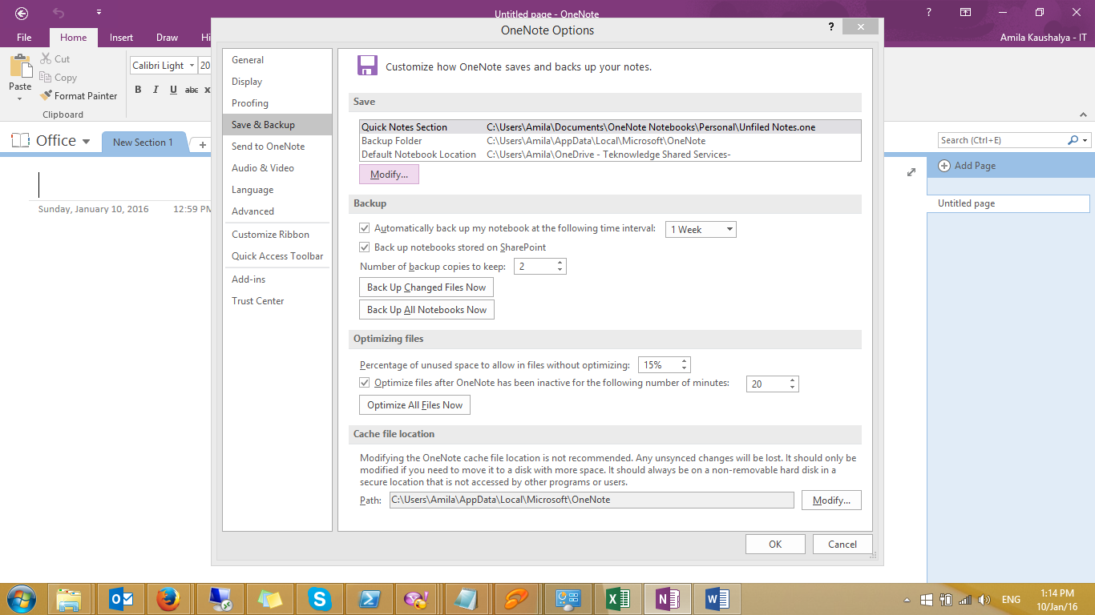

Select a Section click on **Select**

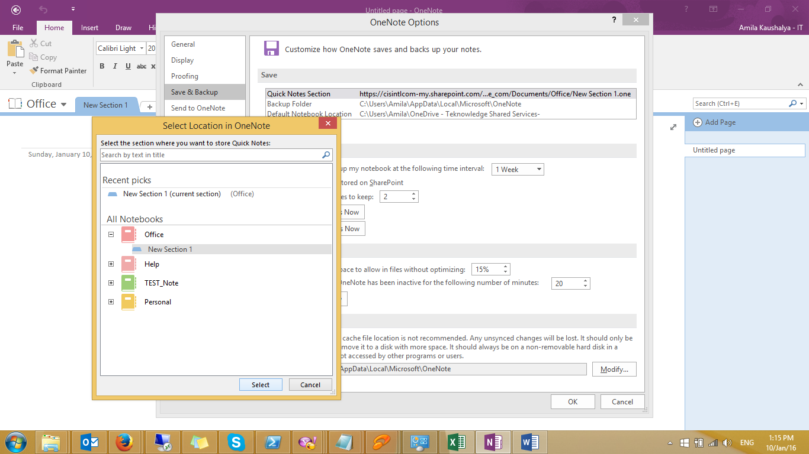

Click OK

You can write down quick notes by single click on “OneNote” icon on System Tray**. Please note Quick Notes always choose default**

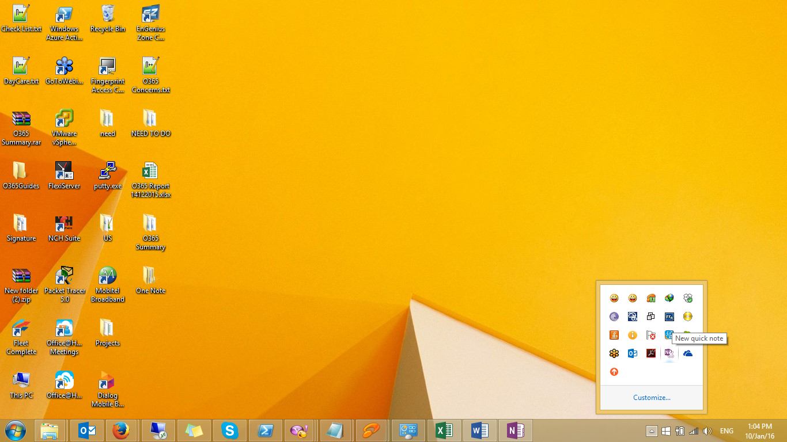

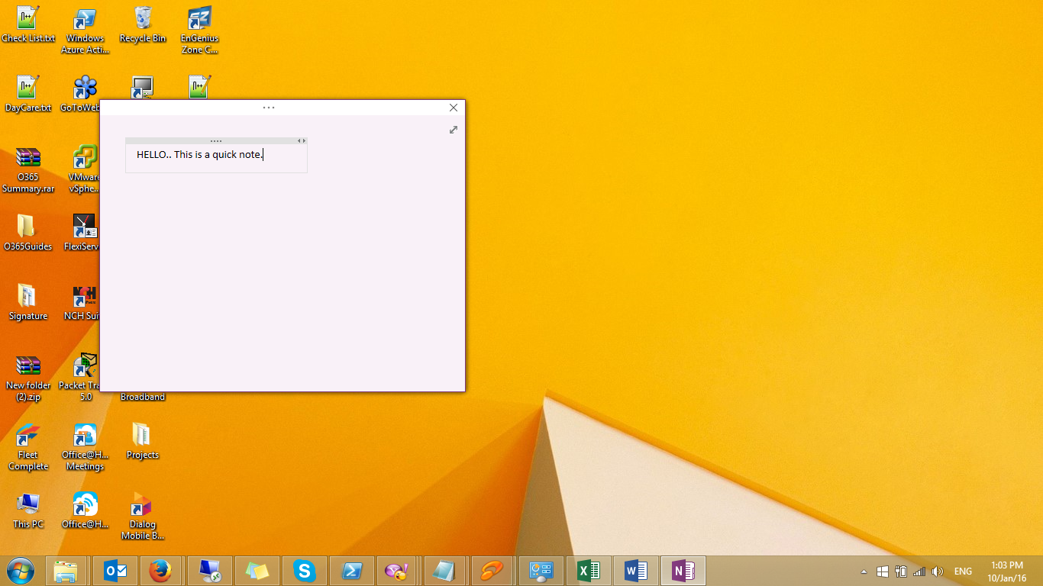

Need to discover more?

Microsoft OneNote Tutorial

<https://www.youtube.com/watch?v=h07qZLLQc4I>

For PC

<https://support.office.com/en-us/article/What-is-OneNote-be6cc6cc-3ca7-4f46-8876-5000f013c563?ui=en-US&rs=en-US&ad=US>

For Mac

<https://docs.com/OfficeTraining/1862/onenote-2016-for-mac-basics-training>